# Introduction

This document provides most of the information needed to run what I call RITE Dos, which stands for Radiotherapy *In vivo* Two-dimensional EPID Dosimetry.

Essentially, RITE Dos works by correlation ratios between the dose at isocentre, and the intensity of the transit signal (i.e. from image taken *through* the phantom) recorded by the central pixels of the electronic portal (MV) imaging device (EPID). This simple idea was first presented by Piermattei et al. (2006, Med Phys), a research group based in Rome, Italy. Currently (2017), their system records in vivo dose for most of their treatments. Of course, the image is formed by the treatment beam itself – no added dose to the patient. They have published dozens of papers on their work throughout the years (key authors: Piermattei, Fidanzio, Cilla, etc.). Their system provides dose in one point only – the isocentre. That is because the correlation ratios are calculated on the central axis (CAX) and there is no simple way of extending this calculation on 2D or 3D.

My PhD work (myself with W.Smith, D.Brown, L.Conroy) consisted in extending this dose calculation from 1D to 2D: from the *isocentre* point to the plane perpendicular to the beam, at the depth of isocentre (sometimes called the *isoplane*). Papers are, are the time of writing, under submission and review (authors: Peca, Smith, Brown). A complete presentation, which include all material available in peer review papers, is my PhD thesis “Development and Clinical Application of a New Two-Dimensional in vivo Dosimetry by Electronic Portal Imaging” (© Stefano Peca 2017).

**DISCLAIMER**:

This document is meant to help you navigate through the process of implementing RITE Dos. It is not exhaustive, it is a guide only.

The code itself is not of professional quality. No doubt, it may be greatly improved to be made more efficient (faster) and more ‘elegant.’ Also, it has no graphic user interface.

Most importantly the dose calculation has limited accuracy. In addition, the more the test conditions (phantom/patient with inhomogeneities and irregular contours; asymmetrical, irregular fields, etc) differ from the reference conditions (simple slab phantom, square fields), the less accurate the dose calculation. Finally, the dose estimation is based on the (planning) CT. If irradiation conditions are different from CT (e.g. anatomy changes in a patient, setup differences, etc), a systematic error in dose estimation will appear.

This code and these instructions are provided “as is” for the benefit of other clinical researchers. The process is divided into two sections: (1) commissioning, and (2) dose estimation. The instructions are based on a Varian Eclipse TPS, and Varian aSI EPID. Steps in the process and in the code may be changed at the user’s discretion. Further reading is chapter 5 of my thesis. Please improve and share, thank you!

Stefano Peca, 2017. [stefanopeca@gmail.com](mailto:stefanopeca@gmail.com)

**Abbreviations, jargon**

Transit image – an EPID image taken through a phantom or patient. If patient, this is an *in vivo* image.

SW – solid water. A slab phantom. Sometimes called plastic water. Can be replaced by sheets of plastic.

w – this symbol refers to thickness of phantom, in terms of water equivalent thickness. If it has no subscripts, it is assumed to be on the CAX. If it is on the ray line going from the source to the imager’s pixel (i,j) it is written as wi,j.

*cine* – or continuous acquisition. this is the imaging modality I used. You may want to make your life easier by using an integrated image instead. It will save you the step I had to do, of summing multiple images

SFS – square field size. Here referred with the symbol l.

TMR – tissue maximum ratio. The TPR with reference to depth of max dose. We used Varian golden data.

# Commissioning of the isocentre point dose estimation

To calculate dose, you need to produce three lookup tables. These are energy- and machine-specific. You will obtain measurements from EPID and TPS (or EPID and ion chamber). Then you will interpolate values, to obtain a finer resolution table. Caution: if you use different parameter values (w, l, d) or different interpolation, you will have to update the MATLAB code.

## The F=S/D lookup table, as a function of thickness (w) and (equivalent) square field size (l)

The most important information you need on your system is the capital F correlation ratio.

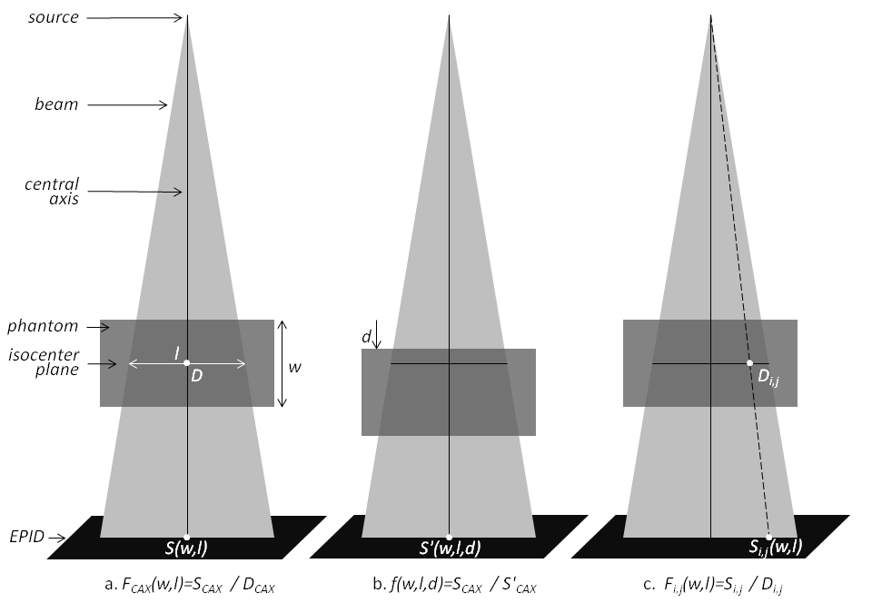

### Get S(CAX) values

Before you do anything else, make new flood field (FF) and dark field (DF) correction, for the energy, dose rate, and imaging modality you will need. SAVE these images, you will need them!

TO GET S VALUES - Take EPID images through the couch AND through 5-40cm of SW. Center (couch+SW) at iso (i.e. if 20cm of SW on couch and w(couch) is 0.6cm, depth should be 20.3cm. Take each image for 100 MU. I used SAD 100, with the (phantom+couch) radiological thickness centered vertically about the isocentre. You may choose to ignore the couch.

### Get D(CAX) values

TO GET D VALUES - Model the same situation in Eclipse. Set SSD = 100-(w(SW)+w(couch))/2. The same number of MU. You may decide to use an ion chamber instead

If you are new to Varian’s Eclipse, the following can help you. ID numbers refer to my institution only.

First, I created a virtual water phantom. Then I applied a beam incident on it, and calculated dose. The geometry must be the same as in 2.1.1.

(Our center: patient ID: Z7720140827 Last Name: VirtualWaterPhantom. )

Ensure there is only 1 field in the plan. Set the field’s beam energy and dose rate as appropriate.

Set **SSD**=100-(w Solid Water + w couch)/2 sequentially. This simulates mid-depth of the total WED.

|  |  |  |  |
| --- | --- | --- | --- |
| **w Solid Water** | **(w Solid Water + w couch)/2** | **SSD to set in Eclipse** | **filename to use (for 5x5)** |
| 5 | 2.8 | 97.2 | l05p0w05p0.dcm |
| 10 | 5.3 | 94.7 | l05p0w10p0.dcm |
| 15 | 7.8 | 92.2 | l05p0w15p0.dcm |
| 20 | 10.3 | 89.7 | **l05p0w20p0.dcm** |
| 25 | 12.8 | 87.2 | **l05p0w25p0.dcm** |
| 30 | 15.3 | 84.7 | **l05p0w30p0.dcm** |
| 35 | 17.8 | 82.2 | **l05p0w35p0.dcm** |
| 40 | 20.3 | 79.7 | **l05p0w40p0.dcm** |
| 45 | 22.8 | 77.2 | **l05p0w40p0.dcm** |

(this takes ~30 minutes per energy)

Set **field size** sequentially to 5x5, 10x10, 15x15, 20x20.

Set MU to the same value which you delivered on the Linac while recording images. (**99 MU**). Calculate dose.

Make sure “**Frontal**” view is selected

Every time you change SSD, RMC on the field: “**Move viewing planes to isocenter/entry point**”

RMC on Dose, choose “**Export dose plane**”.

|  |  |
| --- | --- |
| Dose | absolute |
| Planar Dose Details | **Xsize=26.7622**, points=512 ; **Ysize=20.0717**, points=384 |
| Align matrix with field | choose the appropriate field |
| burn marker pixels in corner | Uncheck |

NOTE: YOU WILL USE THESE TPS PREDICTED DOSE MAPS LATER FOR THE 1D-TO-2D EXTENSION. FOR THIS REASON, IT IS HELPFUL TO HAVE THE DOSE MAPS WITH THE SAME RESOLUTION AS YOUR EPID IMAGES (WHICH IN THIS EXAMPLE IS 512*384).

Export the image into your working directory; Be sure to **name** it correctly as lxxpxwyypy.dcm (see table above).

Repeat for all fields above. Place all .dcm files in a directory such as “6X_600RR”

### Make F table(s)

Obtain values for (FCAX) as a function of phantom thickness (w) and field size (l) by FCAX(w,l)=SEPID(w,l)/DTPS(w,l)

Generally, these tables will be different for different energies (i.e. 6 MV and 15 MV) and for different linear accelerators, even if of the same model. The results for our center for 2 energies and 2 varian machines are in:

*Commissioning_data\F_matrix_interp_with_headings_Unit09_06X_Half.mat*

*Commissioning_data\F_matrix_interp_with_headings_Unit09_15X_Half.mat*

*Commissioning_data\F_matrix_interp_with_headings_Unit10_06X_Half.mat*

*Commissioning_data\F_matrix_interp_with_headings_Unit10_15X_Half.mat*

Here the word “Half” refers to half-resolution setting of the EPID imager, i.e. 512*384, as opposed to full resolution, or 1024*768.

## The f=S/S’ lookup table, as a function of (equivalent) square field size (l) and vertical displacement between the isocentre plane and the radiological mid depth (d)

The second important correlation ratio is the lowercase f. Again, this is defined on the CAX



Piermattei et al. (2006) found that this parameter has very little dependence with w, so that is not further considered. This lookup table is created based on EPID measurements only, no TPS. You should use the same images you obtained to measure F (section 2.1.1). And you will need more images taken with the same SFS (l), and with various values of d. You can do these all with constant thickness w, making it a sensible patient-like thickness like 20cm.

Our center’s results are in

*Commissioning_data\f_little_with_headings_Unit09_06X.mat*

*Commissioning_data\f_little_with_headings_Unit09_15X.mat*

*Commissioning_data\f_little_with_headings_Unit10_06X.mat*

*Commissioning_data\f_little_with_headings_Unit10_15X.mat*

## TMR values

Lastly, you will need a lookup table of TMR values, as a function of thickness (w) and field size. (l).

# Commissioning of the 2D isoplane dose estimation

In section 2 you obtained data to estimate dose at isocentre (1D). Now, we will measure data to extend that calculation to 2D.

The key is to compare profiles along the radial axes of the EPID image (“image profiles”) with profiles of the TPS dose estimation, along the same radial axes (“dose profiles”). For a number of reasons (see especially my thesis, chapter 4) these two profiles differ. Which is of course to be expected, as the image profile is a set of pixel values of an image taken through a block of water, while the dose profile is a set of dose values in the middle of that block of water.

An initial strategy is that presented in Chapter 3 of my thesis. It was abandoned early on, so will not be discussed here. If you wish to investigate it, the scripts are called **DoseCalc_EdgeCorr.m**

The strategy we use is described in Chapters 4 and 5 of my thesis. In short, we use the TPS dose profile as a reference. Then, we take the empirical EPID image profile and convolve it iteratively with various linear combinations of four pre-set Gaussian smoothing kernels, so that the product of the convolution is as close as possible to the reference.

# Calculating delivered dose to patient from *in vivo* EPID images

Open the patient plan in **Eclipse**

### Exporting the CT and plan data

In the context window, select and open (drag into viewing window) the appropriate plan.

“File” – “Export” – “Wizard” – “Plan”. Check “Include image slices of 3D volume”. Uncheck every other option. “Dose” – “None”.

“Finish”: This will export all CT dicom slices (“CT… .dcm”) and one plan file (“RP… .dcm”). Place files in a directory dedicated to the patient (e.g. “Patient001”).

In Matlab workspace, type “CTdata=Import_CT_2;”. This script takes all .dcm files which start with CT and puts them together in a variable (a 3D array) which you called CTdata.

Save the variable “CTdata” as file CTdata.mat in the same directory

Open the script “PROJECTION_2015_A”. Verify the gantry angle (ImAng) is correct. Run it. (approx 4.5 hours).

Select the three WED variables, save them with a filename that denotes the gantry angle (e.g. “WEDs-GA090.mat”).

### Exporting a dose plane image for each beam

Make a note (on paper) of the **MU** of each field you wish to verify. (Note: if you hover with the mouse over the MU value, it provides a decimal value)

Create a **new course**, name it “Physics_RITE_Dos”

Copy the plan you wish to verify from the treatment approved course into the new course.

Set **weights of all fields except the one you wish to verify =0**. This will cause MU of the field to be verified to increase, while all the others go to zero.

For the field you wish to verify, **manually set the MU value equal to what it was initially**. This will change the weighting factor, but that is not a problem.

Click on the window which gives you a **beam’s eye view**. Normally, this translates into:

|  |  |
| --- | --- |
| ***Gantry angle*** | ***Beam’s eye view*** |
| 0° | “Frontal”, “move viewing planes to isocenter”, |
| 270° | “Sagittal”, “move viewing planes to isocenter”, |
| 90° | Rotate “Transversal” by 180°, “move viewing planes to isocenter”, select “Sagittal” window. |
| 180° | Rotate “Transversal” by 180°, “move viewing planes to isocenter”, select “Frontal” window. |
| other | Rotate “Transversal” by the appropriate gantry angle, “move viewing planes to isocenter”, select either “Sagittal” or “Frontal” window as appropriate. |

*(ensure you are actually in a view that coincides with beam’s eye view before proceeding)*

RMC on Dose, choose “**Export dose plane**”.

|  |  |
| --- | --- |
| Dose | absolute |
| Planar Dose Details | **Xsize=26.76053**, points=512 ; **Ysize=20.0704**, points=384 |
| Align matrix with field | choose the appropriate field |
| burn marker pixels in corner | Uncheck |

Export the image into your working directory; **name** it in a recognizable way, e.g. “tpsGA180.dcm”.

Repeat for all fields you wish to verify.